October Learning Challenge:
Design Thinking: Upcycle Your Life!

The design thinking process is a 5-step process used by entrepreneurs around the world to develop creative solutions to a problem! Companies and students may use the design thinking process to creatively tackle challenges and to create a better world through entrepreneurship. For your October Learning Challenge, we challenge you to reflect on the plastic problem within Canada, and apply the design thinking process to find a creative way to upcycle waste.

The Problem
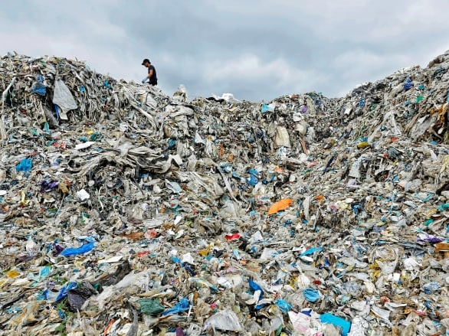
Canadians throw away over 3 million tonnes of plastic waste every year. Canada currently recycles just 9% of its plastic waste every year and while the percentage is going up, it’s still extremely low. The majority of plastic waste in Canada is generated from businesses, organizations, institutions and industry. However, most provincial waste management systems focus only on collection of plastic waste from residential areas. This is a problem as many residents aren’t educated on proper recycling practices

Your Challenge

There are many steps that YOU can take to reduce your waste. One way is through upcycling. Upcycling involves creatively transforming plastic or other forms of waste into new items that can be used. Out of the items that you may find in a recycling or garbage bin, work to find a solution to upgrade your waste!

Looking for inspiration? Take this example: Two UBC undergrad students noticed how many glass bottles get thrown away and sit in landfills despite it being infinitely recyclable without losing its purity or quality. This inspired them to start upcycling glass bottles around campus and making them into candles. They have now grown and expanded their product selection to platters, glasses, candles and more. They take someone’s garbage and give it a new home.

Your Project Instructions

Create a copy of this project template and add it to your Google Drive. Following the steps outlined in the template, apply the Design Thinking Process to develop your idea to upcycle household waste. Then, write a short, persuasive paragraph (4-5 sentences) explaining why your solution is awesome and why people should buy it!

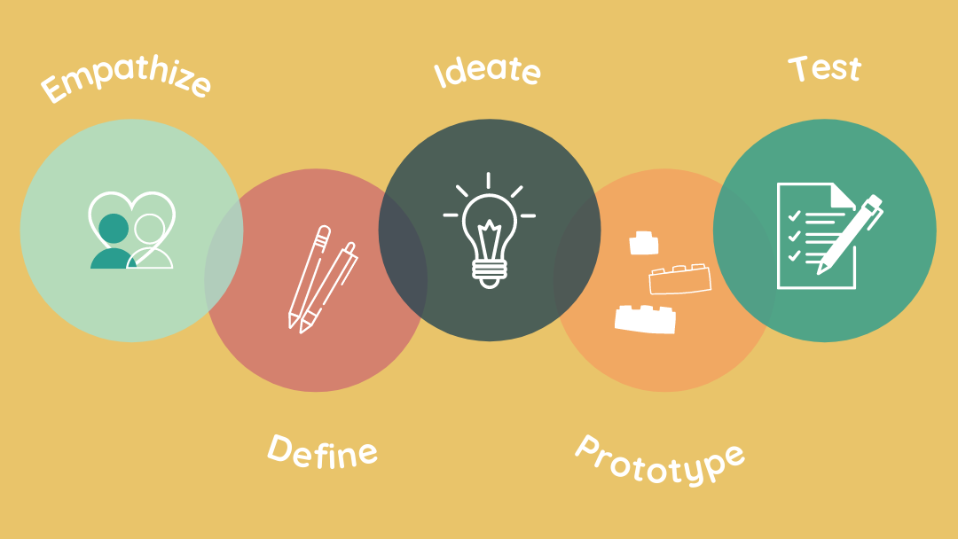

To help you get started, here are some ideas of waste products that you could upcycle…
- Old plastic water bottles
- Yogurt tubs
- Cardboard boxes
- Milk bags/jugs

Learning Challenge Submission
Once you have completed your project, please submit it to the Enspire Team using this Google Form. Please ensure that your Google Slides is set to “anyone with this link can view.”
Your Learning Challenge will be evaluated based on creativity, critical thinking, detail, and presentation. Our Enspire Program team will review all of your submissions, and announce the Learning Challenge Prize Winners within a few weeks!

https://www.canada.ca/en/environment-climate-change/services/managing-reducing-waste/reduce-plastic-waste.html
https://www.gpi.org/glass-recycling-facts#:~:text=Glass%20Facts-,Glass%20is%20100%25%20recyclable%20and%20can%20be%20recycled%20endlessly%20without,for%20furnace%2Dready%20recycled%20glass.

